CLUD FILE MENAGER

1. **Mainly description.**

Głównym celem tego programu jest synchronizacja i przechowywanie plików w chmurze. Aplikacja składa się z serwera oraz aplikacji klienckiej. Cały proces sprawdzania stanu plików na serwerze i komputerze lokalnym jest zautomatyzowane. Proces komunikacji przebiega przez protokół TCP.

The main purpose this program is synchronised and stores files in cloud. Applications consist of server and client app. All process checking state files on the server and local computer is automatic. Communication is realised by TCP protocol

1. **Server cloud file management.**

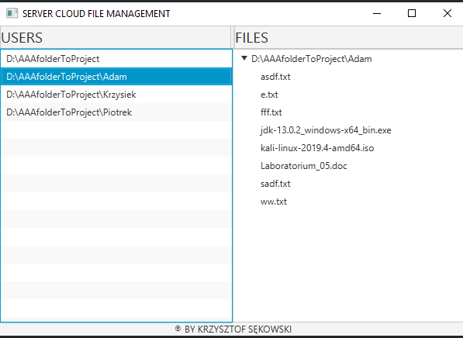

On the left side we can see list of available users on the server. After click on the nick user on left side we can see list of files and directory on the right side.

**User’s aplications**

How run this program?

You must run this program from comend line/terminl etc. And give to parametr to start this program.

Frist argument will be your login. Secend argument will be path to your directory with files which you wont shered and synchronized with the server platform.

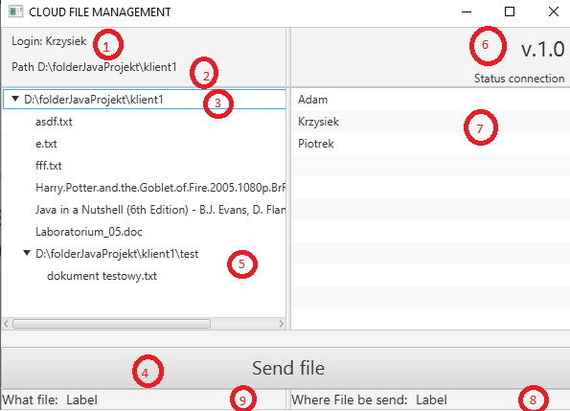

1. Your User name -> this parameter set by first main argument
2. Path to user files -> this parameter set by second main argument
3. Tree view -> this list present users files and directory structure. Before send file you must chose one from this list, and click field must be name of some file, can’t be name of directory
4. Button -> after click this file will be send
5. DropDown -> this line present how are show directory in directory
6. Version -> this label shows actual version program
7. List of users->this list consists of nick users. Before send some file we must chose one user from this list.
8. Destinations user to send the file-> After chose user name from the list which assigned ‘7’ you should see your chose in this filed
9. File to sends -> After chose file from the list assigned ‘3’ you should see your chose in this field